

Prepared by:

**Gerber Technology**

**YuniquePLM**

**Administration Folder**

The Administrator Panel is where licenses and permissions are managed within the YuniquePLM application. It is also where language translations are controlled. This area of the application should be restricted to most users except the designated system administrators within the company. System administrators should be individuals with a good understanding of the various groups of users working in the application and the functions that they will need to perform. To access the administrator panel, click on the header located on the far right of the YuniquePLM desktop.

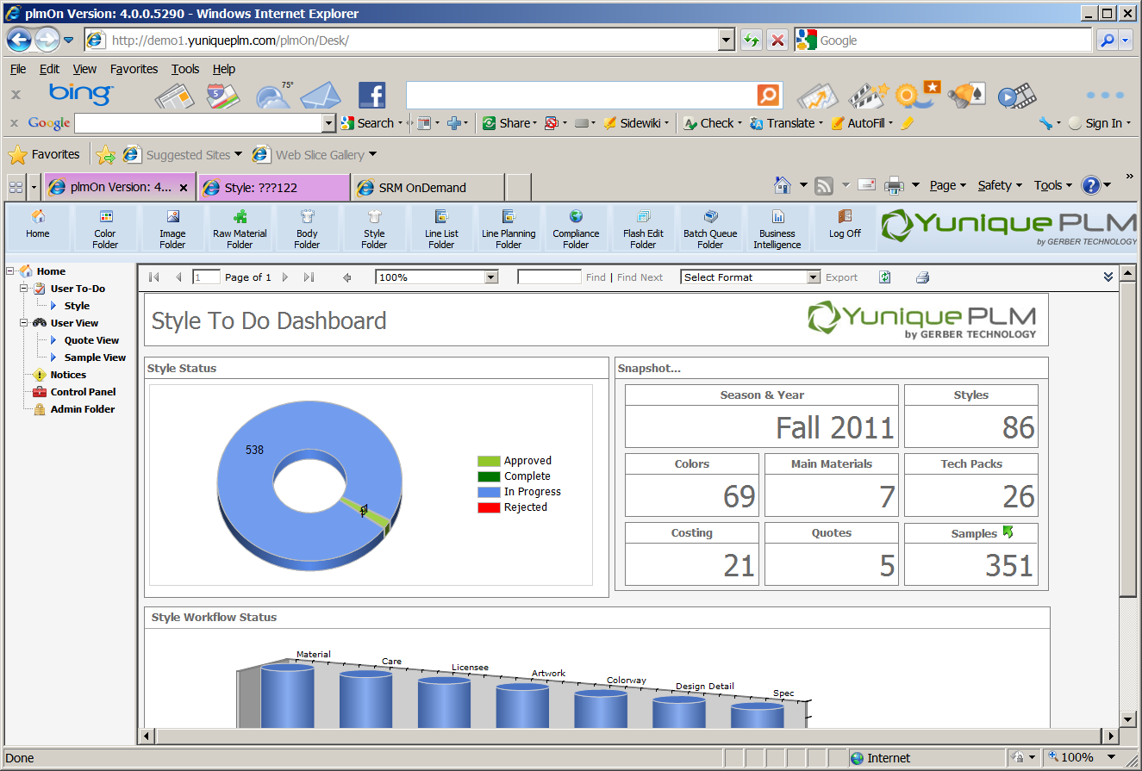

The administrator panel will open in a new explorer window. The nodes on the left display the types of data managed within the administrator panel. Highlighting one of the individual nodes will display the data on the right hand side of the explorer window.

**Team**

To add individual users to the system, click on the Team node on the left side of the window. Then click on the New button across the top of the screen.

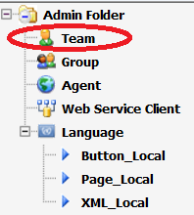

Enter the name of the individual for which the log in is being created, and select the language preference for the user. This will be the language that is seen each time the user logs into the application and will also affect the currency display where applicable. Make sure to place a check mark in the Active field in order to allow the log in to be used once it is created. Place a check mark in the administrator box, if the user will be performing administrator functions. If the user will be accessing the YuniquePLM application from outside of the company IP address, place a check mark in the box to the right of External Access. Click the Add button across the top of the screen to store the new record.

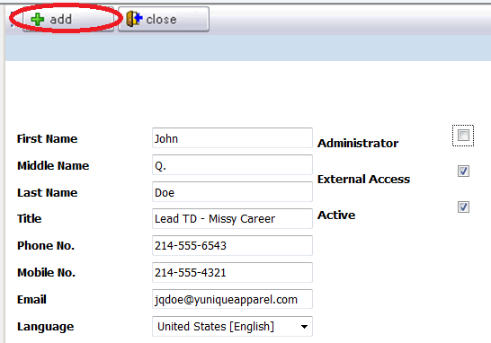

Once the user account has been created, a user name and password can be set by clicking on the Options button across the top of the window.

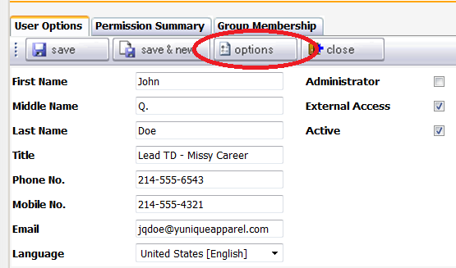

Type the username for the account. Then set a password consisting of at least six characters including at least one number and one of the following symbols: ! @ # $ % ^ & * ( 0 _+ = - { } [ ] \ | : ; ? >< , . / . Click Save to store the record and Close to return to the administrator panel.

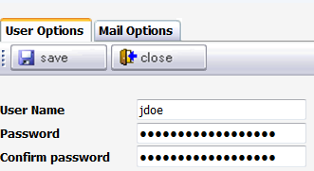

User permissions are based on the Group Memberships. Individual user accounts can be assigned to groups by clicking on the Group Membership tab and then clicking the Add button.

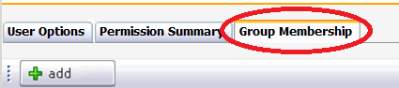

Place a check mark to the left of all of the groups in which the user being added should be included. Click the Save button across the top of the window to store the record.

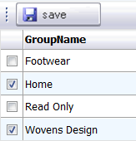

**\* Note:** User accounts can be created and saved prior to having any user groups and permissions established.

The Permissions Summary tab will display the type of access that the new user account will have to each of the YuniquePLM modules.

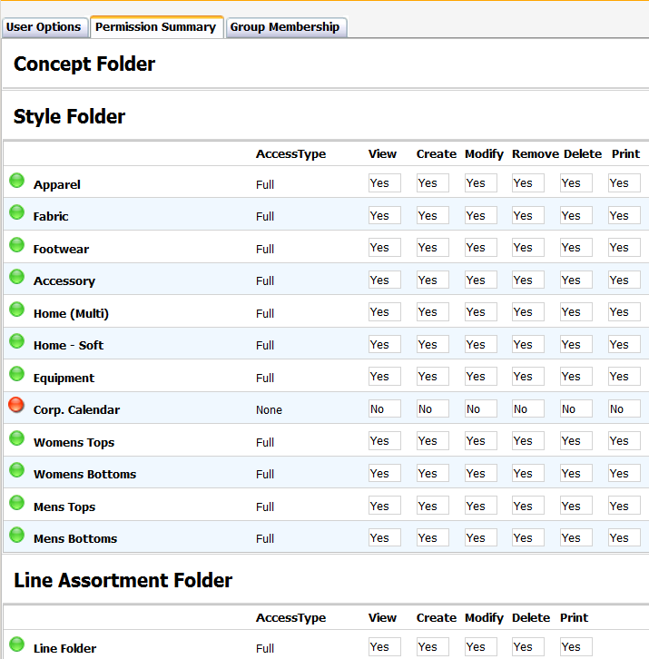

**Group**

Permissions to specific modules within the YuniquePLM application are established by setting up user groups. Highlight the Groups node on the left side of the Administrator Panel and click the New button across the top of the window.

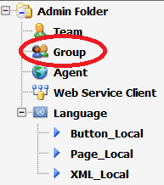

Enter a name for the group for which permissions are being established, and then give a description for the group. Place a check mark to the right of the Active lable to make sure that the new group is available for use in the system. Click the Add button across the top of the window to store the record in the database.

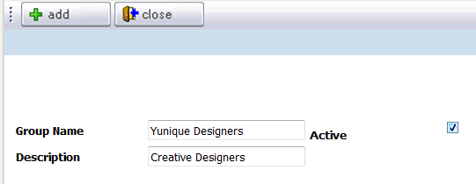

By default permission to each module is set as “locked” or hidden to the users included in the new group. This is displayed as a red “X” to the left of each of the folder nodes displayed on the left side of the window.

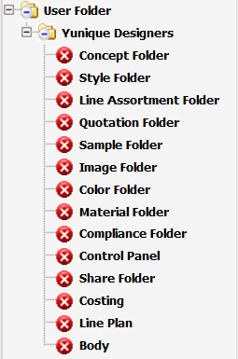

If individual users have already been added to the system, they will be in the Available Users list on the left. They can be moved to the Selected Users list on the right by using the green arrow controls in the center.

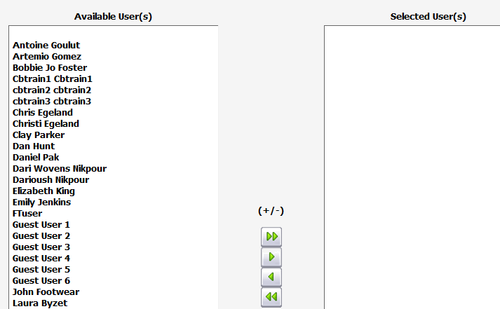

To give the new user group permission to a specific folder, select the folder name from the left side of the window then click on the Unlock Folder button across the top of the window.

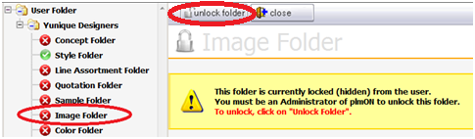

Once the folder is unlocked permissions to specific areas within a folder can be established. The exact permissions available may vary for each folder type. Select None, Partial or Full access to the areas within a given folder. Then click the Save button across the top of the window.

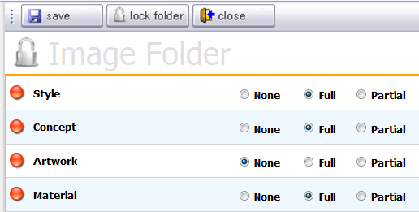

Once a folder has been unlocked the symbol will change from a red “X” to a green check mark.



**Agent**

The Agent node is available for non-employee users that will be contributing information via the Yunique SRM software application. This will include agent partners and vendor partners. To add a new agent group, highlight the Agent node on the left navigation and click on the New button across the top of the window.

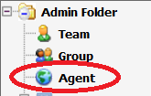

Enter all known information about the new group and then click the Add button across the top of the window to store the record in the database. When entering a password make sure it consists of at least six characters and contains at least one number and one of the following symbols: ! @ # $ % ^ & * ( 0 _+ = - { } [ ] \ | : ; ? >< , . / . Click Save to store the record and Close to return to the administrator panel.

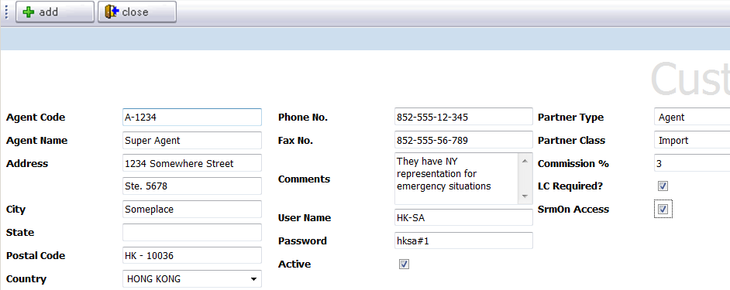

Once the main agent group is established, individual user contacts can be associated with the agent. These could be agent contacts or vendor contacts. Select the appropriate tab and then click on the Add button to enter the user information.

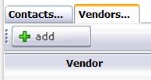

Enter the name and contact information for the individual user being added and click on the Add button. Make sure that an email is entered for each individual user that is included as part of the new agent group.

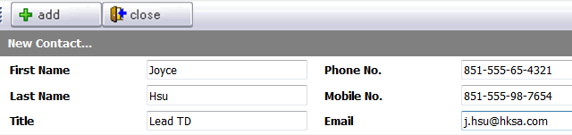

Once all information and contacts have been entered for the new agent group, click on the Save button across the top of the window and then the Close button to return to the main Administrator Panel. The options button is available should the password need to be changed for any reason. But since the password is set at the agent level this should not be necessary.



**\* NOTE:**  An agent group will share a single user name and password among all users included in that group. When the individual users are added, their email address will be included as a required part of the login information stored in the system. The common user name and password combined with the individual user email address will indicate the specific user that has signed into the system.

**Language**

The Language node is available so that global users are able to access the system in their native language. By default all controls, schema files, etc. will be seen in the United States version of the English Language. Each additional language will need to be populated with the correct translation of data. Once completed, each user will see all controls, headers, etc. in the language that has been set in the user account profile, located in the Team folder. English US is also available for translation, so that companies can see their own corporate verbiage if desired.

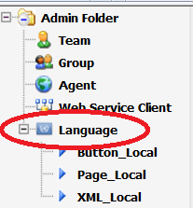

The language folder is broken out into 3 sections for translation. The sections are:

* Button_Local – For translation of verbiage seen on the control buttons presented. For example:



* Page_Local – For translation of verbiage that is schema driven on any working page within the application. For example, any of the header labels and column names. This is data that might be configured slightly differently for each company.

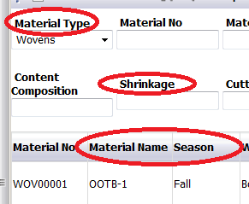

* XML_Local - For translation of verbiage that is not schema driven, but rather would be consistent part of the software application for all companies. **Example:**

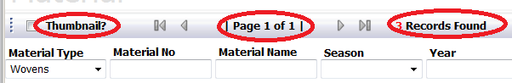

To begin translating the data, highlight the appropriate language folder on the left side of the explorer window. On the right side of the window all of the corresponding text strings will be displayed.

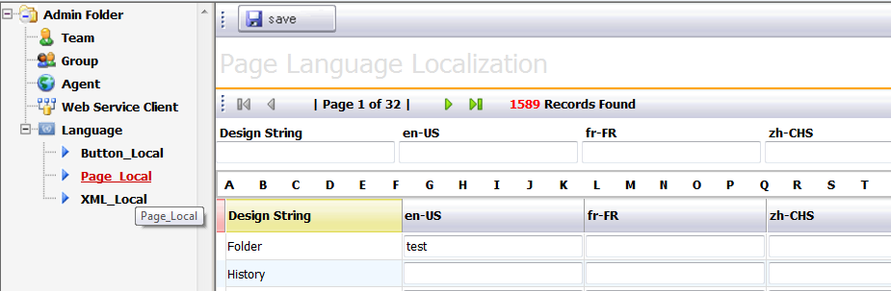

Each text string will be listed under the column Design String with the original version of the text. To the right, each of the available languages will be listed as a column header. Each column will have an available field where the translation of the original string can by entered.

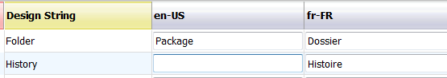

Once all translations are complete, click on the Save button across the top of the window.

